Critical Commentary: Call for Contributions
Volume 6, Number 1: Special edition on ‘Student partnership’
Volume 6, Number 2: Disciplinary and cross-disciplinary research
Editorial Board Membership
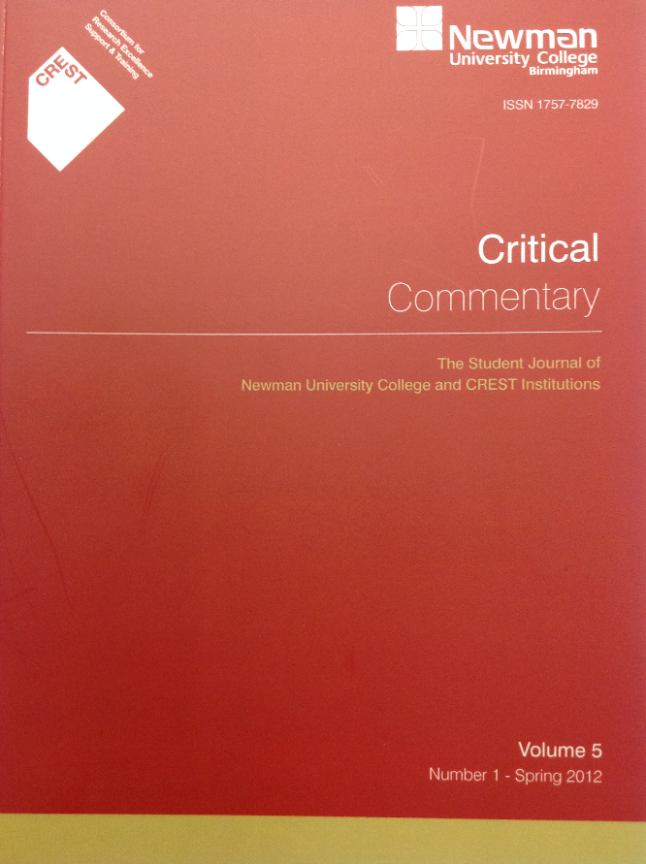
Critical Commentary is the Student Journal of Newman University published under the aegis of Newman University, in collaboration with the Consortium for Research Excellence, Support and Training (CREST). Critical Commentary exemplifies the development of student research and scholarship at Newman University and participating CREST institutions. Critical commentary was first published in 2007, making it one of the earliest established student research journals in the UK. Each issue features academic work of a high standard, by undergraduate and taught postgraduate students, reflecting the diversity and quality of the work being produced throughout Newman University and CREST institutions.
Critical Commentary welcomes articles from undergraduate and taught postgraduate students which discuss topics of importance and interest from all areas of the member institutions. Articles may be written from a variety of academic and professional perspectives and should be informed by theory and research. A key priority is to produce an interdisciplinary academic journal that captures many of the debates and dilemmas shaping contemporary society. All articles are subject to a rigorous peer review process and, importantly, all submissions receive full developmental feedback.
Articles must not exceed 7000 words excluding references, and should be accompanied by an abstract of no more than 200 words, together with three to five keywords. Articles should not have been sent to another journal for consideration. Critical Commentary will hold the copyright of the article if it is subsequently published. Further guidelines for publication can be found online at http://www.newman.ac.uk/graduate-school/3181

CALL FOR PAPERS. Volume 6, Number 1: Special edition on ‘Student partnership’
The next edition of Critical Commentary is now inviting papers on the theme of ‘Student partnership’. Many GuildHE institutions, including Newman University, are running schemes intended to support student partnership working in research and academic development. Examples include York St John’s students as researchers scheme, Worcester’s students as partners projects and Winchester’s student fellows scheme.
If you are interested in submitting a paper arising out of such work or reflecting and theorising about student partnership working in Higher Education, in the first instance students are encouraged to speak with their partnership tutor and then to contact a member of the Critical Commentary editorial team.
Papers need to be submitted by Friday 10th April 2015 to: criticalcommentary@newman.ac.uk

CALL FOR PAPERS. Volume 6, Number 2: Disciplinary and cross-disciplinary research
Further editions of Critical Commentary will be publishing articles from student research reflecting the diversity and quality of the work being produced throughout Newman University and CREST institutions. Articles may be written from a variety of academic and professional perspectives as long as they are informed by theory and research. Papers on disciplinary or cross-disciplinary research should be submitted for Volume 6, Number 2, by October 2015. You may, for example, wish to consider publishing an article following the completion of a successful dissertation. In the first instance please speak to your dissertation tutor for guidance and then contact a member of the editorial board.
Papers for Volume 6, Number 2, need to be submitted by Friday 30th October 2015 to: criticalcommentary@newman.ac.uk

CALL FOR CONTRIBUTIONS: Membership of Editorial Board
We are looking to renew and refresh the Editorial Board of Critical Commentary. We would be particularly interested in applications from new researchers and PhD students with an interest in gaining experience of the peer reviewing process. We would also invite applications from student partnership practitioners and those with a student research leadership role within their CREST institution. While we have an established editorial board we are seeking to grow, there is also the opportunity to contribute to Critical Commentary as an associate editor on a particular volume or number. Should you be interested in either of these opportunities please send a short letter or email of application, a supporting reference from your CREST institutional contact and your CV, to Dr John Peters, Head of Academic Practice, Newman University, at: j.peters@newman.ac.uk

For any specific or general queries about Critical Commentary please contact:
John Peters, Editor (email: j.peters@newman.ac.uk) Room DW117 Newman University
Claire Monk, Assistant Editor (email: c.monk@newman.ac.uk) Room DW121 Newman University
John Howard, Newman University Graduate School (email: john.howard@newman.ac.uk) Room DW120

